BRICE PRAIRIE CONSERVATION ASSOCIATION

OVER TWENTY YEARS OF HELPING OUR LOCAL WATERFOWL

WOOD DUCK AND HOODED MERGANSER REPORT

2009 - 2011

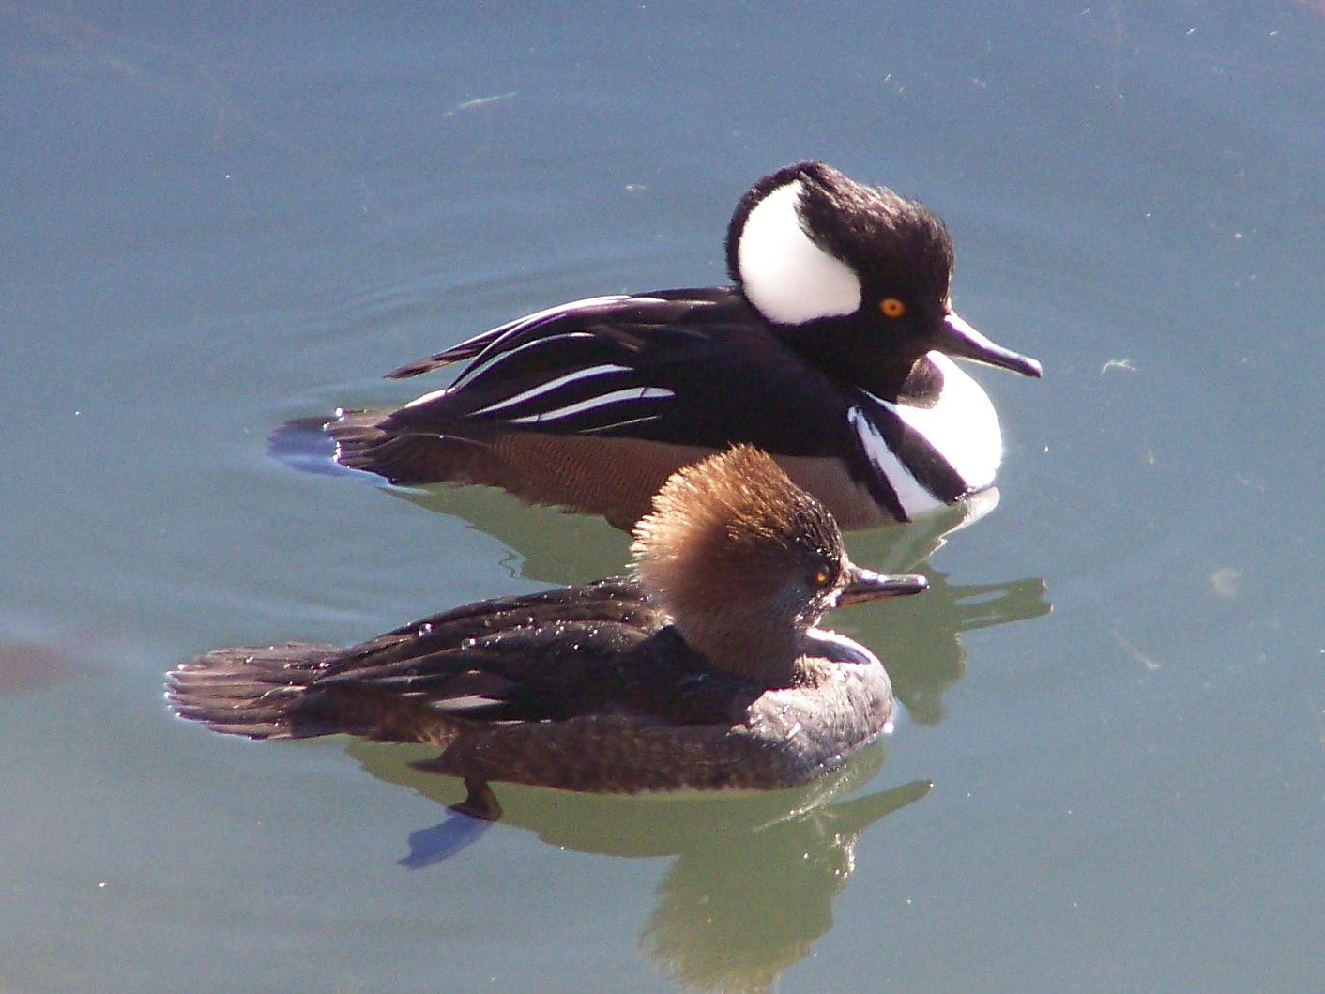

BY

JOHN WETZEL AND MARC SCHULTZ

WWW.BRICEPRAIRIECONSERVATION.ORG

ONALASKA, WISCONSIN
BRICE PRAIRIE CONSERVATION ASSOCIATION

WOOD DUCK AND HOODED MERGANSER REPORT

- - 2011

OVER TWENTY YEARS OF HELPING OUR LOCAL WATERFOWL

This report represents the twenty-forth year that members of the Brice Prairie Conservation Association have monitored wood duck boxes and reported on results. Over these three years, 14 members and Boy Scout Troop 21 assisted in monitoring up to 365 boxes. Between 33 and 44 percent of the boxes were used by wood ducks or hooded mergansers each year (Tables 1).

Since 2006, the numbers of boxes available, as reported in Table 4, represent the actual numbers that were checked in that particular year. In some of the prior years, this column represents the total number of boxes checked that year plus the number put out in prior years. Many of our older boxes have been lost, replaced or are no longer being checked on a yearly basis.

Between 86 and 88 percent of the 24 to 52 boxes that were used by wood ducks from 2009 – 2011 were successful – hatched at least one duckling. A total of 837 wood ducks were produced over this period for a total production of 10,217 wood ducks since 1988 (Table 4).

Another 84 to 108 boxes were used annually by hooded mergansers over this period with 70 – 81 percent hatching at least one duckling. Of the 2,971 hooded merganser eggs laid, 1,982 hatched (Tables 3). Over the past twenty-four years we have documented 17, 611 hooded mergansers that have been produced in our boxes (Table 4).

In total, BPCA has confirmed the production of 27,828 wood duck or hooded merganser ducklings since 1988 that have been produced from the club's metal wood duck boxes (Table 4). The average annual box use rate since 2006 has been 42 percent.

The BPCA also sells blue bird and wood duck boxes. If you are interested in purchasing a box and helping wildlife, please check our website and contact a Board member.

BRICE PRAIRIE CONSERVATION ASSOCIATION
2009

TABLE 1: TOTAL WOOD DUCK BOXES – AVAILABLE AND USED

Boxes %
Name Location Avail. Used Used

Fred Craig Sunset Farms 5 5 100

Al Daus Lake Onalaska Dike 19 9 47

Greg Egan Dakota, MN 17 12 70

Rick Knuth Chipmunk Coulee Cr. 11 7 64

Mike Lanquist BP/Marges’ Dikes 9 5 56

Amanda Marco Girl Scout Camp 14 11 78

Greg Marco Eleva 59 12 20

Leif Marking French Is./Gills C./BP 68 23 34

Jim Nissen Upper Miss. Refuge – MN 43 27 63

Marc Schultz/JW Upper Lake Ona. 83 23 28

Leif Tolokken French Slough/ Buffalo Co. 20 18 90

John Wetzel Van Loon/ S. of Tremp. 17 7 41

____ ____ ____
Totals 365 159 44

BRICE PRAIRIE CONSERVATION ASSOCIATION
2009
TABLE 2: WOOD DUCK PRODUCTION

Name Nests % Eggs %
Attempts Hatched Hatched Laid Hatched* Hatched

Fred Craig 1 1 100 6 6 100

Greg Egan 5 4 80 57 41 72

Al Daus 2 2 100 3 3 100

Rick Knuth 11 7 64 73 60 82

Mike Lanquist 2 2 100 20 19 95

Amanda Marco 3 3 100 21 18 86

Greg Marco 9 7 78 105 97 92

Leif Marking 9 9 100 115 102 88

Jim Nissen 2 2 100 17 17 100

Leif Tolokken 8 8 100 58 44 76

____ ____ ____ ____ ____ ____
Totals 52 45 86 475 407 86

* Hatched and Left Box (Ducklings Produced)

BRICE PRAIRIE CONSERVATION ASSOCIATION

2009

TABLE 3: HOODED MERGANSER PRODUCTION

Name Nests % Eggs %
Attempts Hatched Hatched Laid Hatched* Hatched

Fred Craig 4 4 100 44 41 93

Al Daus 4 4 100 47 31 66

Greg Egan 7 6 86 77 63 82

Mike Lanquist 3 2 67 29 12 41

Amanda Marco 8 7 88 54 32 59

Greg Marco 3 3 100 42 38 90

Leif Marking 14 13 93 173 147 85

Jim Nissen 27 21 78 365 272 74

Marc Schultz/JW 23 13 56 224 101 45

Leif Tolokken 8 8 100 104 67 64

John Wetzel 7 7 100 65 56 86

____ ____ ____ ____ ____ ____
Totals 108 88 81 1,224 860 70

*Hatched and Left Box (Ducklings Produced)

BRICE PRAIRIE CONSERVATION ASSOCIATION

2010

TABLE 1: TOTAL WOOD DUCK BOXES – AVAILABLE AND USED

Boxes %
Name Location Avail. Used Used

Fred Craig Sunset Farms 8 3 38

Al Daus Lake Onalaska Dike 19 5 26

Rick Knuth Chipmunk Coulee Cr. 11 6 54

Mike Lanquist BP /Marges’ Dikes 10 3 30

Amanda Marco Girl Scout Camp 14 8 57

Dick Marco/JW Browns Marsh 11 3 27

Greg Marco Eleva 53 9 17

Leif Marking French Is./Gills C./BP 67 21 31

Jim Nissen Upper Miss. Refuge – MN 43 23 53

Marc Schultz/JW Upper Lake Ona. 43 15 35

Troop 21 Bike Trail to Tremp. 26 6 23

John Wetzel Van Loon/ S. of Tremp. 17 4 24

_____ _____ _____
Totals 322 106 33

BRICE PRAIRIE CONSERVATION ASSOCIATION
2010
TABLE 2: WOOD DUCK PRODUCTION

Name Nests % Eggs %
Attempts Hatched Hatched Laid Hatched* Hatched

Al Daus #1 1 100 1 1 100

Rick Knuth 6 4 67 43 34 79

Mike Lanquist 1 1 100 8 6 75

Jim Nissen +1 1 100 10 7 70

Greg Marco 3 3 100 36 35 97

Leif Marking 10 10 100 141 132 94

Troop 21 2 1 50 8 8 100
____ ____ ____ ____ ____ ____
Totals 24 21 88 247 223 90

*Hatched and Left Box (Ducklings Produced)

#Also had 10 merganser eggs.

+Also had 14 Merganser egg. Incubated by a hooded merganser.

BRICE PRAIRIE CONSERVATION ASSOCIATION
2010

TABLE 3: HOODED MERGANSER PRODUCTION

Name Nests % Eggs %
Attempts Hatched Hatched Laid Hatched* Hatched

Fred Craig 3 3 100 33 26 78

Al Daus # 5 5 100 41 36 88
Mike Lanquist 2 2 100 18 11 61

Amanda Marco 8 5 62 56 28 50

Dick Marco/JW 3 1 33 20 5 25

Greg Marco 6 5 83 42 41 98

Leif Marking 11 7 64 105 68 65

Jim Nissen +23 19 82 273 201 74

Marc Schultz/JW 15 9 60 149 73 49
Troop 21 4 2 50 20 15 75

John Wetzel 4 1 25 40 4 10
_____ _____ _____ _____ _____ _____
Totals 84 59 70 797 508 64

*Hatched and Left Box (Ducklings Produced)
#One box also had a single wood duck egg.
+One box also had 10 wood duck eggs. Incubated by a hooded merganser.

BRICE PRAIRIE CONSERVATION ASSOCIATION

2011

TABLE 1: TOTAL WOOD DUCK BOXES – AVAILABLE AND USED

Boxes %
Name Location Avail. Used Used

Al Daus Lake Onalaska Dike 19 16 84

Mike Lanquist BP/Marges’ Dikes 10 6 60

Jason Ludwigson Root River, MN 2 1 50

Amanda Marco Girl Scout Camp 14 6 43

Dick Marco/JW Browns Marsh 11 2 18

Greg Marco Eleva 53 8 15

Leif Marking French Is./Gills C./BP 67 21 31

Jim Nissen Upper Miss. Refuge – MN 43 27 63

Marc Schultz/JW Upper Lake Ona. 69 21 30

Leif Tolokken French Slough/ Buffalo Co. 16 12 75

John Wetzel Van Loon/ S. of Tremp. 17 6 35
_____ _____ _____
Totals 321 126 39

BRICE PRAIRIE CONSERVATION ASSOCIATION
2011
TABLE 2: WOOD DUCK PRODUCTION

Name Nests % Eggs %
Attempts Hatched Hatched Laid Hatched* Hatched

Al Daus 2 1 50 18 15 83

Mike Lanquist 1 1 100 6 6 100

Jason Ludwigson 1 1 100 11 6 54

Greg Marco 3 3 100 40 39 98

Leif Marking 12 10 83 155 107 69

Marc Schultz/JW 1 1 100 12 11 92

Leif Tolokken 4 4 100 26 15 58

John Wetzel 1 1 100 8 8 100

____ ____ ____ ____ ____ ____
Totals 25 22 88 276 207 75

*Hatched and Left Box (Ducklings Produced)

BRICE PRAIRIE CONSERVATION ASSOCIATION
2011
TABLE 3: HOODED MERGANSER PRODUCTION

Name Nests % Eggs %
Attempts Hatched Hatched Laid Hatched* Hatched

Al Daus 14 13 93 101 59 58

Mike Lanquist 5 5 100 24 13 54

Amanda Marco 6 5 83 58 43 74

Dick Marco/JW 2 0 0 8 0 0

Greg Marco 5 5 100 62 49 79

Leif Marking 9 5 56 86 54 63

Jim Nissen 27 22 81 286 215 75

Marc Schultz/JW 20 14 70 225 129 57

Leif Tolokken 8 4 50 53 24 45

John Wetzel 5 3 60 47 28 60

____ ____ ____ ____ ____ ____
Totals 101 76 75 950 614 65

*Hatched and Left Box (Ducklings Produced)

BRICE PRAIRIE CONSERVATION ASSOCIATION
TABLE 4: DUCKLING PRODUCTION 1988 - 2011

Boxes Wood Ducks Mergansers Total
Year Available Used Produced Produced Production

1988 60 1 10 - 10
1989 100 5 49 - 49
1990 160 13 99 - 99
1991 175 26 169 44 213
1992 225 38 248 95 343
1993 275 51 212 158 370
1994 350 66 320 312 632
1995 400 118 552 483 1,035
1996 425 131 651 577 1,228
1997 500 137 461 672 1,133
1998 535 159 595 912 1,507
1999 550 180 644 1,093 1,737
2000 575 197 776 1,262 2,038
2001 580 182 596 1,134 1,730
2002 600 245 693 1,614 2,307
2003 640 243 704 1,489 2,193
2004 670 231 645 1,366 2,011
2005 675 241 605 1,532 2,137
2006 334 156 332 793 1,125
2007 394 153 464 1,009 1,473
2008 413 192 555 1,084 1,639
2009 365 159 407 860 1,267
2010 322 106 223 508 731
2011 321 126 207 614 821

Totals 10,217 17,611 27,828

